Article Title
First Authorᵃ (first name and surname), Second Authorᵇ (first name and surname), …, Corresponding Authorᶜ,*

ᵃOrganization, Address, Postal Code, City, Country, author.one@email.com
^{b}Organization, Address, Postal Code, City, Country, author.two@email.com
^{c},*Organization, Address, Postal Code, City, Country, corresponding.author@email.com

ABSTRACT
This document specifies the format of the paper submitted for the conference “Welding Technology Day 2026”. The contributions will be published in a printed proceedings volume and possibly also in electronic form. The paper must be written entirely in accordance with these instructions.

INTRODUCTION

Authors are expected to prepare their manuscripts carefully, without grammatical, spelling, or stylistic errors. The paper should be between 4 and a maximum of 6 pages in length.

Paper Format
A uniform appearance of all papers will be ensured by following this template. Please note that the template is in A4 format, with 25 mm margins on all four sides.
All paragraphs are single-spaced, with a first-line indent of 10 mm. The position and font of headings and subheadings should follow this template. There are no blank lines between paragraphs. All fonts are predefined.

Header, Footer, Page Numbers
Do not modify headers, footers, or page numbering.

Font
The paper must be written in Times New Roman, font size 12. Fonts such as Times, Symbol, or Arial may be used in figures. It is recommended that the font size in figures is not smaller than 10 pt. Please do not use any other fonts.

Figures and tables
Figure and table captions must be sufficiently descriptive to clearly relate them to the text. Figures and tables must not be included unless they are referenced in the text.

Tabele 1: Example of a table
Dates | Description
5. marec 2026 | Paper submission deadline
3. april 2026 | PowerPoint presentation submission
15. april 2026 | Welding Technology Day

All tables and figures should be placed as close as possible to the text where they are mentioned. They must be numbered consecutively using Arabic numerals (tables separately from 1 to n, and figures separately from 1 to n). The table title is centered above the table, while the figure caption is centered below the figure.
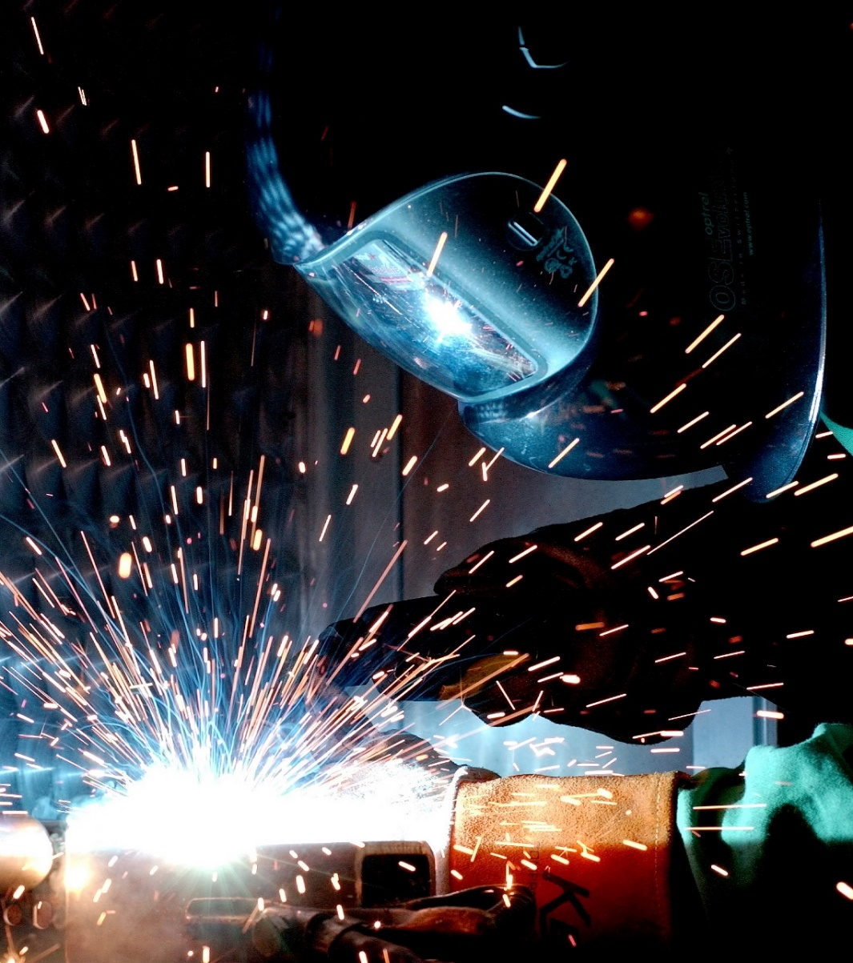
Figure 1: Example of a Figure – Welder during welding

Please use “In Line with Text” formatting: click on the image, then select the Picture Tools – Format tab, and in the Text Wrapping menu choose In Line with Text.

Equations
Each equation must be placed on a separate line, with spacing above and below. Equations must be numbered consecutively, with the number aligned to the right margin, as shown below:

(1)

References
References should be cited in square brackets, e.g. [1]. The reference list must be ordered according to the sequence of appearance in the text. Examples of reference formatting are given in the References section.

Article Submission
The MS Word paper should be prepared in .doc or .docx format and sent by e-mail no later than 5 March 2026.

Acknowledgments
If the author wishes to acknowledge individuals or organizations in connection with the published paper, this can be done in this section. Otherwise, this section should be removed.

REFERENCES
- H. L. Langhaar, S. C. Chu, Development in Theoretical and Applied Mechanics, Pergamon, New York, 1970, pp. 84-100. (za knjigo)
- T. V. Vo, D. R. Edwards, "Development of In-Service Inspection Priorities for PWR", Nucl. Technol., 106, 1994, pp. 253-259. (za članek v reviji)
- J. E. Dendy Jr., B. Swartz, B. Wendroff, "Computing travelling wave solutions of a nonlinear heat equation". In: J. J. H. Miller, (Ed.), Topics in Numerical Analysis, Vol. III, Academic Press, London, 1977, pp. 447-463. (za članek v knjigi)
- R. Baltus, A. Rubbers, "Piping reliability improvement through passive seismic supports", Proc. Int. Conf. Nuclear Energy in Central Europe '99, Portorož, Slovenia, September 6-9, Nuclear Society of Slovenia, 1999, pp. 251-258. (za članek na konferenci)

